Day 5-Lab Programming DAA

1. 0/1 Knapsack Problem – Dynamic Programming
Aim
To implement the 0/1 Knapsack Problem using Dynamic Programming and find the maximum profit that can be obtained within the given capacity.
Algorithm
- Start with the weights, values, and knapsack capacity.
- Create a DP table dp[i][w].
- Initialize all values to 0.
- For each item, check whether its weight is less than or equal to the current capacity.
- If possible, choose the maximum of including or excluding the item.
- Otherwise, exclude the item.
- Return dp[n][capacity].
Program & Output
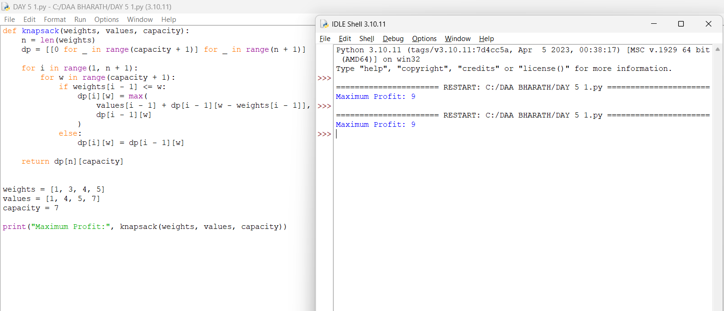

2. Travelling Salesperson Problem – Dynamic Programming
Aim
To implement the Travelling Salesperson Problem using Dynamic Programming and find the minimum cost tour visiting all cities exactly once.
Algorithm
- Represent the cities and distances using a cost matrix.
- Use a bit mask to represent visited cities.
- Start from city 0.
- Recursively visit every unvisited city.
- Calculate the minimum cost for each possible route.
- Return to the starting city after visiting all cities.
- Select the minimum total cost.
Program & Output
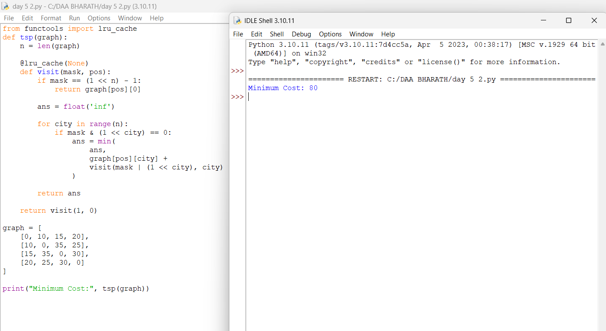

3. Optimal Binary Search Tree – OBST
Aim
To construct an Optimal Binary Search Tree using Dynamic Programming and find the minimum search cost.
Algorithm
- Store the frequency of each key.
- Create a cost table.
- Initialize the cost of a single key with its frequency.
- Consider chains of increasing length.
- Try every key as the root.
- Calculate left subtree cost, right subtree cost, and total frequency.
- Select the minimum cost.
- Return the cost of the complete tree.
Program & Output
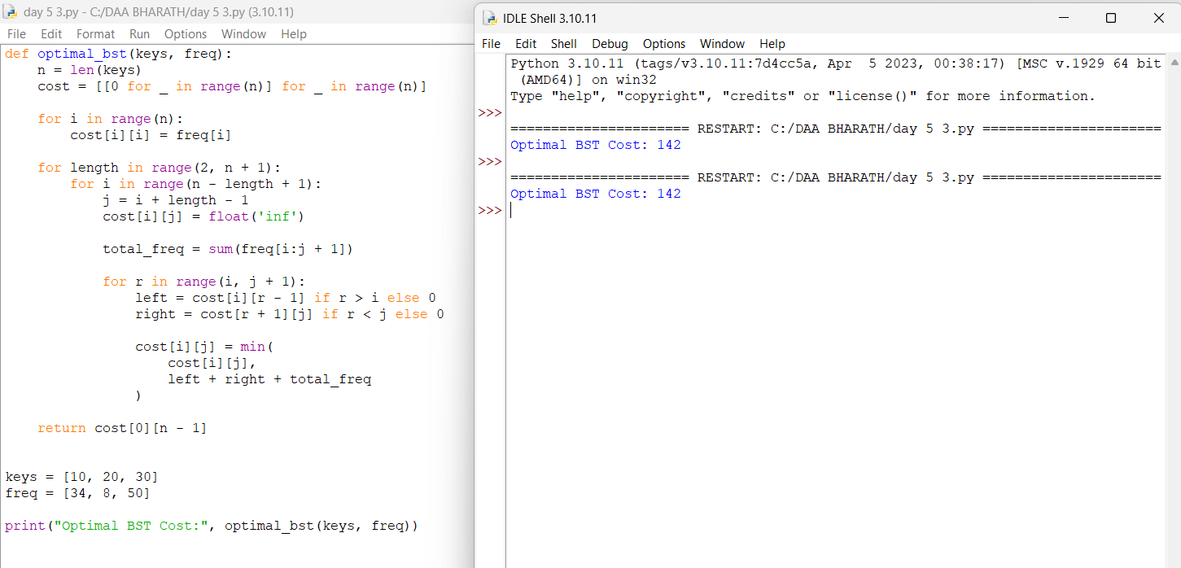

4. 0/1 Knapsack Problem
Aim
To implement the 0/1 Knapsack Problem using Dynamic Programming and determine the maximum possible profit.
Algorithm
- Read weights, values, and capacity.
- Create a DP table.
- Consider each item one by one.
- If the item fits, calculate both inclusion and exclusion cases.
- Store the maximum value.
- If the item does not fit, copy the previous value.
- Return the final maximum profit.
Program & Output
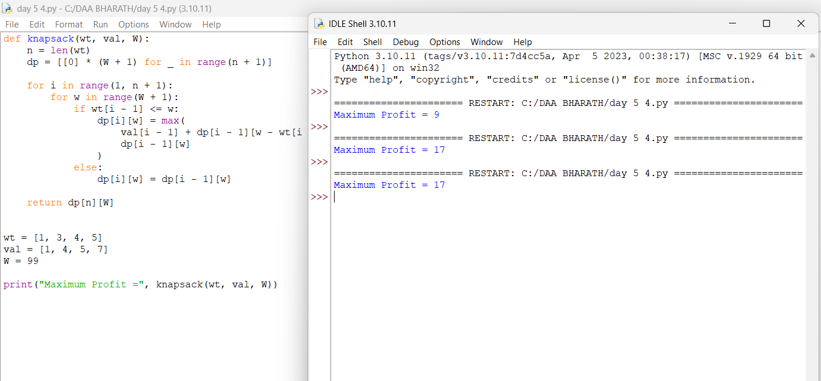

5. 0/1 Knapsack Using Memoization
Aim
To implement the 0/1 Knapsack Problem using Memoization and find the maximum achievable profit.
Algorithm
- Initialize a memoization table with -1.
- Check whether capacity or number of items is zero.
- If the result is already stored, return it.
- If the item fits, consider including and excluding it.
- Store the maximum result in the memo table.
- If the item does not fit, exclude it.
- Return the calculated maximum profit.
Program & Output
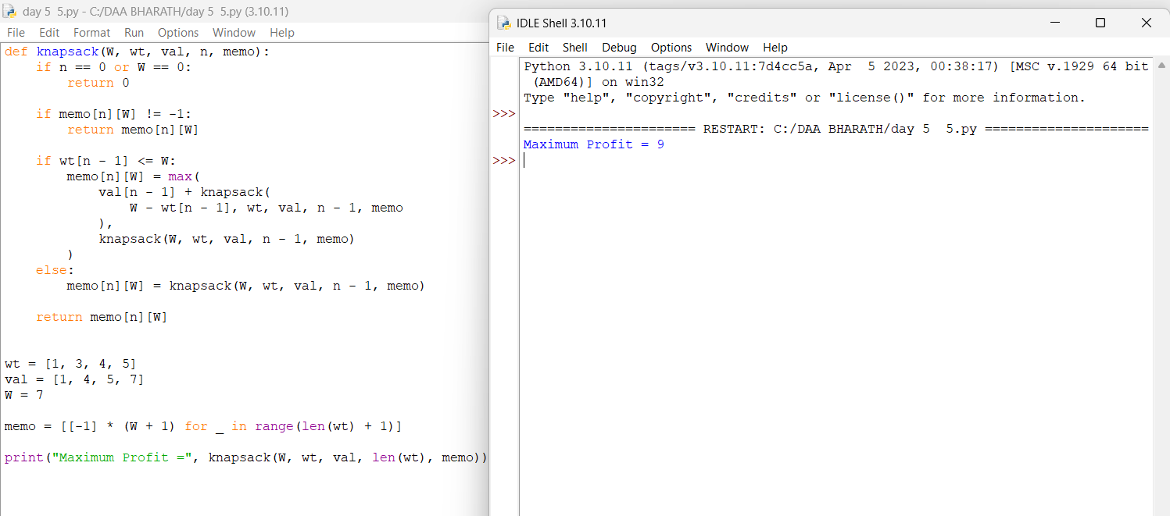

6. Subset Sum Problem
Aim
To implement the Subset Sum Problem using Dynamic Programming and determine whether a subset with the given target sum exists.
Algorithm
- Read the array and target sum.
- Create a Boolean DP table.
- Set the first column as True.
- For each element, check whether it can be included.
- Store True if the target can be formed.
- Continue until all elements are processed.
- Return the final Boolean result.
Program & Output
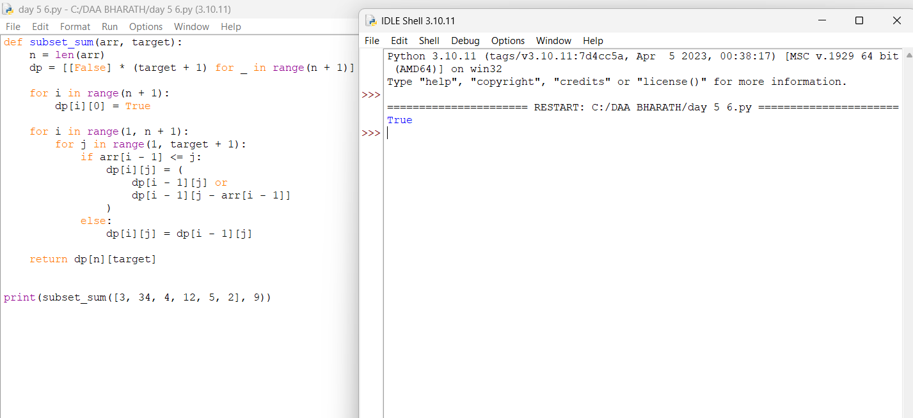

7. Travelling Salesperson Problem – DP Version
Aim
To implement the Travelling Salesperson Problem using Dynamic Programming with Bit Masking and find the minimum tour cost.
Algorithm
- Store the distance matrix.
- Represent visited cities using a bit mask.
- Start from city 0.
- Select each unvisited city.
- Recursively calculate the minimum route.
- Return to city 0 after visiting all cities.
- Print the minimum tour cost.
Program & Output
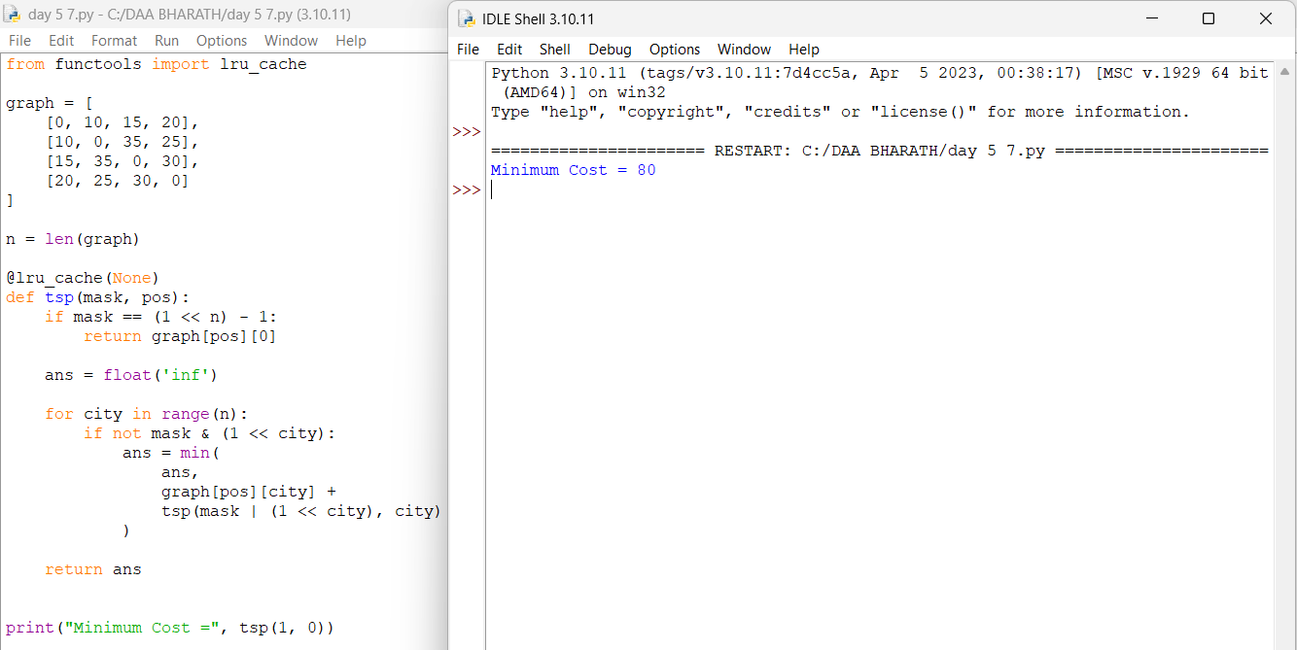

8. Travelling Salesperson Using DP Table
Aim
To implement the Travelling Salesperson Problem using a Dynamic Programming Table and determine the minimum travelling cost.
Algorithm
- Create a DP table using subsets of cities.
- Initialize the starting city with cost 0.
- For every visited-city set, consider all current cities.
- Try every unvisited city as the next city.
- Update the DP table with the minimum cost.
- After visiting all cities, add the cost of returning to city 0.
- Select the minimum total cost.
Program & Output
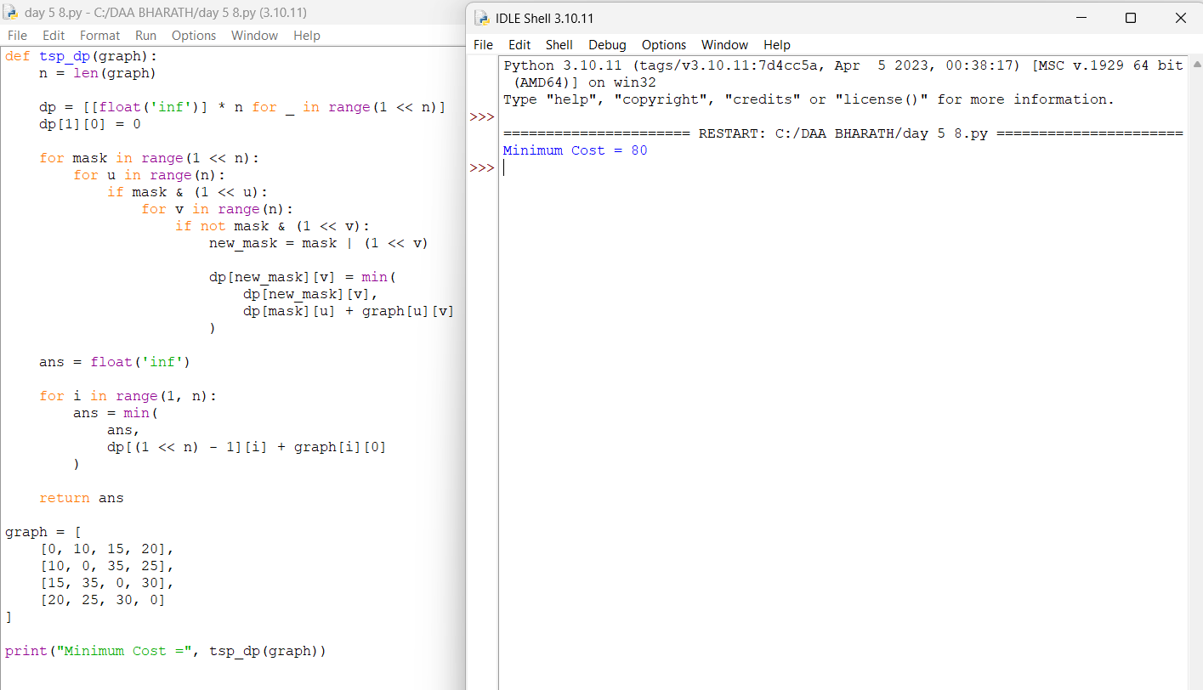

9. Optimal Binary Search Tree – OBST
Aim
To implement the Optimal Binary Search Tree using Dynamic Programming and calculate the minimum search cost.
Algorithm
- Read the frequencies of the keys.
- Create a cost matrix.
- Initialize the diagonal values with the corresponding frequencies.
- Consider subtrees of increasing lengths.
- Select every key as the root.
- Calculate left and right subtree costs.
- Add the total frequency.
- Store the minimum cost.
Program & Output
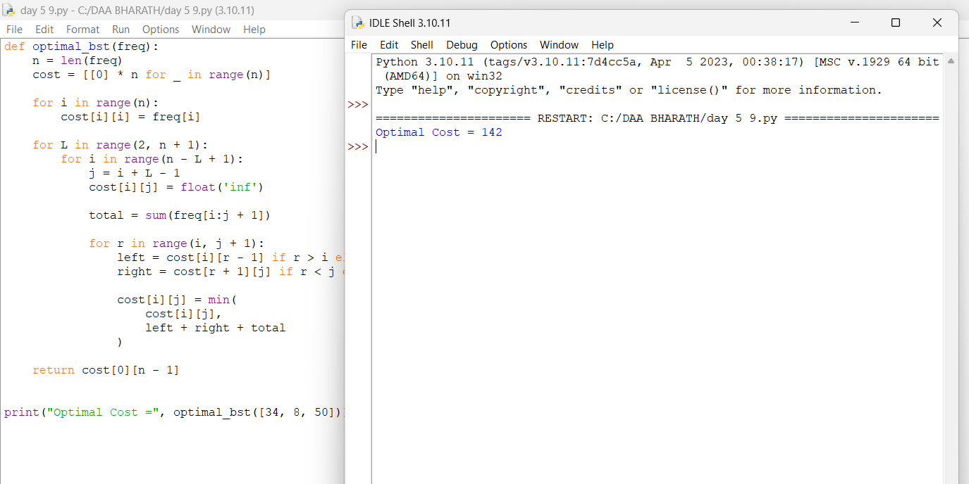

10. Matrix Chain Multiplication
Aim
To implement Matrix Chain Multiplication using Dynamic Programming and find the minimum number of scalar multiplications.
Algorithm
- Read the dimensions of the matrices.
- Create a DP table.
- Consider chains of increasing lengths.
- Try every possible position for splitting the chain.
- Calculate the multiplication cost for each split.
- Store the minimum cost.
- Return the minimum number of scalar multiplications.
Program & Output
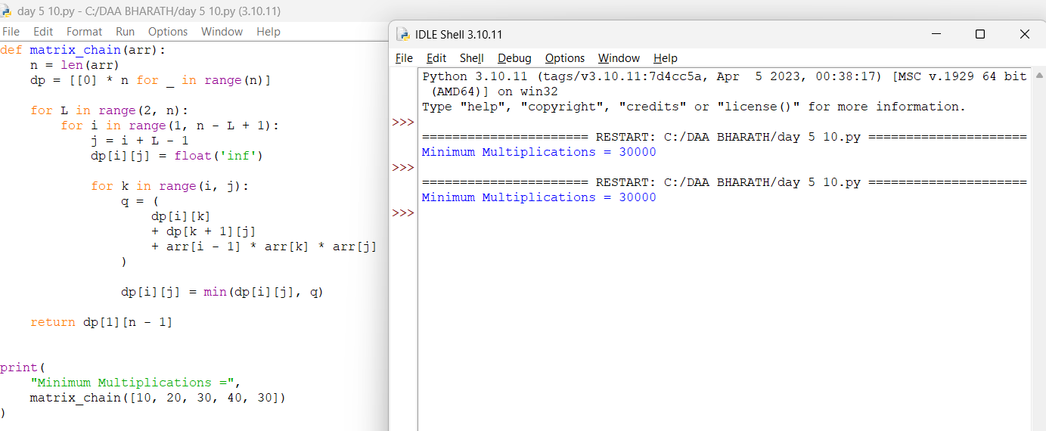

11. Coin Change – Minimum Coins
Aim
To implement the Coin Change Problem using Dynamic Programming and find the minimum number of coins required to make a given amount.
Algorithm
- Read the available coin denominations and amount.
- Create a DP array.
- Set dp[0] = 0.
- For every amount, check all available coins.
- Select the minimum number of coins.
- Continue until the required amount is reached.
- Return the minimum number of coins.
Program & Output
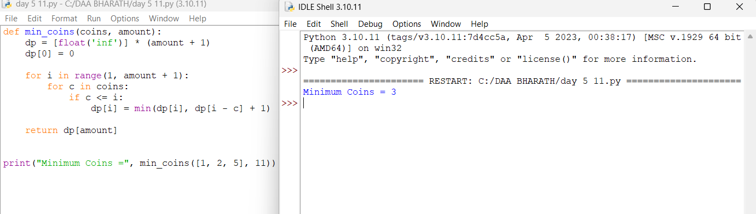

12. Rod Cutting Problem
Aim
To implement the Rod Cutting Problem using Dynamic Programming and find the maximum revenue obtained by cutting a rod optimally.
Algorithm
- Read the prices for different rod lengths.
- Create a DP array.
- Initialize all values to zero.
- Consider every possible rod length.
- Try all possible first cuts.
- Calculate the maximum revenue for each length.
- Return the maximum revenue for the complete rod.
Program & Output
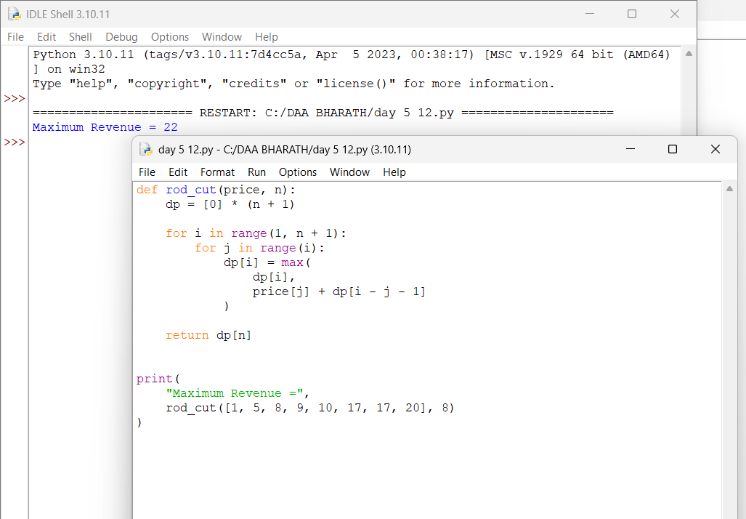

13. Minimum Cost Path
Aim
To implement the Minimum Cost Path Problem using Dynamic Programming and find the minimum cost required to reach the bottom-right cell.
Algorithm
- Read the cost matrix.
- Create a DP table.
- Initialize the first cell with its cost.
- Calculate cumulative costs for the first row.
- Calculate cumulative costs for the first column.
- For each remaining cell, add its cost to the minimum of the top and left cells.
- Return the bottom-right value as the minimum path cost.
Program & Output
